Preparation of Articles for the Journal of Control (English Edition): Single-spaced, Double Column (January 2022)
A. Author¹*, B. Author^{1,2}, and C. Author³
¹ Departments of Automatic Control, Faculty of Engineering, Lund University, Sweden (e-mail: author@control.lth.se).
² Department of Systems and Control Engineering, Faculty of Electrical Engineering, K. N. Toosi University of Technology, Tehran, Iran (e-mail: author@kntu.ac.ir).
³ National Research Institute for Metals, Tsukuba, Japan (e-mail: author@nrim.go.jp).

*Corresponding Author
Received 31 March 2020 | Received in revised form 24 November 2020 | Accepted 12 February 2021
Abstract—These instructions give you basic guidelines for preparing articles for the Journal of Control (English Edition). Use this document as a template. Paper titles should be written in uppercase and lowercase letters, not all uppercase. Avoid writing long formulas with subscripts in the title; short formulas that identify the elements are fine (e.g., "Nd–Fe–B"). Full names of authors are preferred in the author field but are not required. Put a space between the authors’ initials. The abstract must be a concise yet comprehensive reflection of what is in your article. In particular, the abstract must be self-contained, without abbreviations, footnotes, or references. The abstract must be written as one paragraph, and should not contain displayed mathematical equations or tabular material. The abstract should include three or four different keywords or phrases, which will help readers find it. It is important to avoid over-repetition of such phrases as this can result in a page being rejected by search engines. Ensure that your abstract reads well and is grammatically correct.

Keywords: Enter key words or phrases in alphabetical order, separated by commas.

- Introduction
T
HIS document is a template for Microsoft Word versions 6.0 or later. If you are reading a paper or PDF version of this document, please download the electronic version from the Journal of Control (English Edition) Web site at https://jocee.kntu.ac.ir/page/19/Guide-for-Authors. So you can use it to prepare your manuscript.

Guidelines For Manuscript Preparation
Prepare your paper in full-size format, on US letter paper (215.9 by 279.4 mm).
Type sizes and typefaces: Follow the type sizes specified in Table I. As an aid in gauging type size, 1 point is about 0.35 mm. The size of the lowercase letter “j” will give the point size. Times New Roman is the preferred font.
1) US letter margins (inches): top = 25.4 mm, bottom = 25.4 mm, side = 25.4 mm.
2) US letter margins (mm): top = 25.4 mm, bottom = 25.4 mm, side = 25.4 mm.
Paragraph indentation is 3.5 mm (0.14 in).
Left- and right-justify your columns.
Use automatic hyphenation and check the spelling.
Digitize and electronically paste all figures into the document.
To insert images in Word, position the cursor at the insertion point and either use Insert | Picture | From File or copy the image to the Windows clipboard and then Edit | Paste Special | Picture (with “float over text” unchecked).

Abbreviations and Acronyms
Define abbreviations and acronyms the first time they are used in the text, even after they have already been defined in the abstract. Abbreviations such as IEEE, SI, ac, and dc do not have to be defined. Abbreviations that incorporate periods should not have spaces: write “C.N.R.S.,” not “C. N. R. S.” Do not use abbreviations in the title unless they are unavoidable (for example, “IEEE” in the title of this article).

Footnotes
Number footnotes separately in superscripts (Insert Footnote). Place the actual footnote at the bottom of the column in which it is cited; do not put footnotes in the reference list (endnotes). Use letters for table footnotes (see Table I).

Other Recommendations
Use a zero before decimal points: “0.25,” not “.25.” Use “cm³,” not “cc.” Indicate sample dimensions as “0.1 cm × 0.2 cm,” not “0.1 × 0.2 cm².” The abbreviation for “seconds” is “s,” not “sec.” Use “Wb/m²” or “webers per square meter,” not “webers/m².” When expressing a range of values, write “7 to 9” or “7-9,” not “7~9.”
A parenthetical statement at the end of a sentence is punctuated outside of the closing parenthesis (like this). Avoid contractions; for example, write “do not” instead of “don’t.” The serial comma is preferred: “A, B, and C” instead of “A, B and C.”
If you wish, you may write in the first person singular or plural and use the active voice (“I observed that ...” or “We observed that ...” instead of “It was observed that ...”). Remember to check spelling. If your native language is not English, please get a native English-speaking colleague to carefully proofread your paper.

MATH
If you are using Word, use the Microsoft Equation Editor for equations in your paper (Insert | Object | Create New | Microsoft Equation). “Float over text” should not be selected.

Equations
Number equations consecutively with equation numbers in parentheses flush with the right margin, as in (1). First, use the equation editor to create the equation. Then select the “Equation” markup style. Press the tab key and write the equation number in parentheses. To make your equations more compact, you may use the solidus ( / ), the exp function, or appropriate exponents. Use parentheses to avoid ambiguities in denominators. Punctuate equations when they are part of a sentence, as in
(1)

Be sure that the symbols in your equation have been defined before the equation appears or immediately following. Italicize symbols (T might refer to temperature, but T is the unit tesla). Refer to “(1),” not “Eq. (1)” or “equation (1),” except at the beginning of a sentence: “Equation (1) is ... .”

Units
Use SI (MKS) units. The SI unit for magnetic field strength H is A/m. However, if you wish to use units of T, either refer to magnetic flux density B or magnetic field strength symbolized as µ₀H. Use the center dot to separate compound units, e.g., “A·m².”

Guidelines for Graphics Preparation

Types of Graphics
Format and save your graphics using a suitable graphics processing program that will allow you to create the images as PostScript (PS), Encapsulated PostScript (.EPS), Tagged Image File Format (.TIFF), Portable Document Format (.PDF), or Portable Network Graphics (.PNG) sizes them, and adjusts the resolution settings. If you created your source files in one of the following programs you will be able to submit the graphics without converting to a PS, EPS, TIFF, PDF, or PNG file Microsoft Word, Microsoft PowerPoint, or Microsoft Excel. Though it is not required, it is strongly recommended that these files be saved in PDF format rather than DOC, XLS, or PPT. Doing so will protect your figures from common font and arrow stroke issues that occur when working on the files across multiple platforms.

Sizing of Graphics
Most charts, graphs, and tables are one column wide (3.5 88 millimeters) or page wide (181 millimeters). The maximum depth a graphic can be is 216 millimeters. When choosing the depth of a graphic, please allow space for a caption. Figures can be sized between column and page widths if the author chooses, however it is recommended that figures are not sized less than column width unless when necessary.

Color Space
The term color space refers to the entire sum of colors that can be represented within the said medium. For our purposes, the three main color spaces are Grayscale, RGB (red/green/blue) and CMYK (cyan/magenta/yellow/black). RGB is generally used with on-screen graphics, whereas CMYK is used for printing purposes.
All color figures should be generated in RGB or CMYK color space. Grayscale images should be submitted in Grayscale color space. Line art may be provided in grayscale OR bitmap colorspace. Note that “bitmap colorspace” and “bitmap file format” are not the same thing. When bitmap color space is selected, .TIF/.TIFF/.PNG are the recommended file formats.

Accepted Fonts Within Figures
When preparing your graphics you should use of one of the following Open Type fonts: Times New Roman, Helvetica, Arial, Cambria, and Symbol. If you are supplying EPS, PS, or PDF files all fonts must be embedded. Some fonts may only be native to your operating system; without the fonts embedded, parts of the graphic may be distorted or missing.
A safe option when finalizing your figures is to strip out the fonts before you save the files, creating “outline” type. This converts fonts to artwork what will appear uniformly on any screen.

Using Labels Within Figures

Figure Axis labels
Figure axis labels are often a source of confusion. Use words rather than symbols. As an example, write the quantity “Magnetization,” or “Magnetization M,” not just “M.” Put units in parentheses. Do not label axes only with units. As in Fig. 1, for example, write “Magnetization (A/m)” or “Magnetization (Am⁻¹),” not just “A/m.” Do not label axes with a ratio of quantities and units. For example, write “Temperature (K),” not “Temperature/K.”
Multipliers can be especially confusing. Write “Magnetization (kA/m)” or “Magnetization (10³ A/m).” Do not write “Magnetization (A/m) × 1000” because the reader would not know whether the top axis label in Fig. 1 meant 16000 A/m or 0.016 A/m. Figure labels should be legible, approximately 8 to 10 point type.

Referencing a Figure or Table Within Your Paper
TABLE I
Units for Magnetic Properties
Symbol | Quantity | Conversion from Gaussian and  CGS EMU to SI ª
Φ | magnetic flux | 1 Mx → 10⁻⁸ Wb = 10⁻⁸ V·s
B | magnetic flux density,  magnetic induction | 1 G → 10⁻⁴ T = 10⁻⁴ Wb/m²
H | magnetic field strength | 1 Oe → 10³/(4π) A/m
m | magnetic moment | 1 erg/G = 1 emu  → 10⁻³ A·m² = 10⁻³ J/T
M | magnetization | 1 erg/(G·cm³) = 1 emu/cm³  → 10³ A/m
4πM | magnetization | 1 G → 10³/(4π) A/m
σ | specific magnetization | 1 erg/(G·g) = 1 emu/g → 1 A·m²/kg
j | magnetic dipole  moment | 1 erg/G = 1 emu  → 4π × 10⁻¹⁰ Wb·m
J | magnetic polarization | 1 erg/(G·cm³) = 1 emu/cm³  → 4π × 10⁻⁴ T
χ, κ | susceptibility | 1 → 4π
χ_{ρ} | mass susceptibility | 1 cm³/g → 4π × 10⁻³ m³/kg
μ | permeability | 1 → 4π × 10⁻⁷ H/m  = 4π × 10⁻⁷ Wb/(A·m)
μ_{r} | relative permeability | μ → μ_{r}
w, W | energy density | 1 erg/cm³ → 10⁻¹ J/m³
N, D | demagnetizing factor | 1 → 1/(4π)
Vertical lines are optional in tables. Statements that serve as captions for the entire table do not need footnote letters.
ªGaussian units are the same as cg emu for magnetostatics; Mx = maxwell, G = gauss, Oe = oersted; Wb = weber, V = volt, s = second, T = tesla, m = meter, A = ampere, J = joule, kg = kilogram, H = henry.
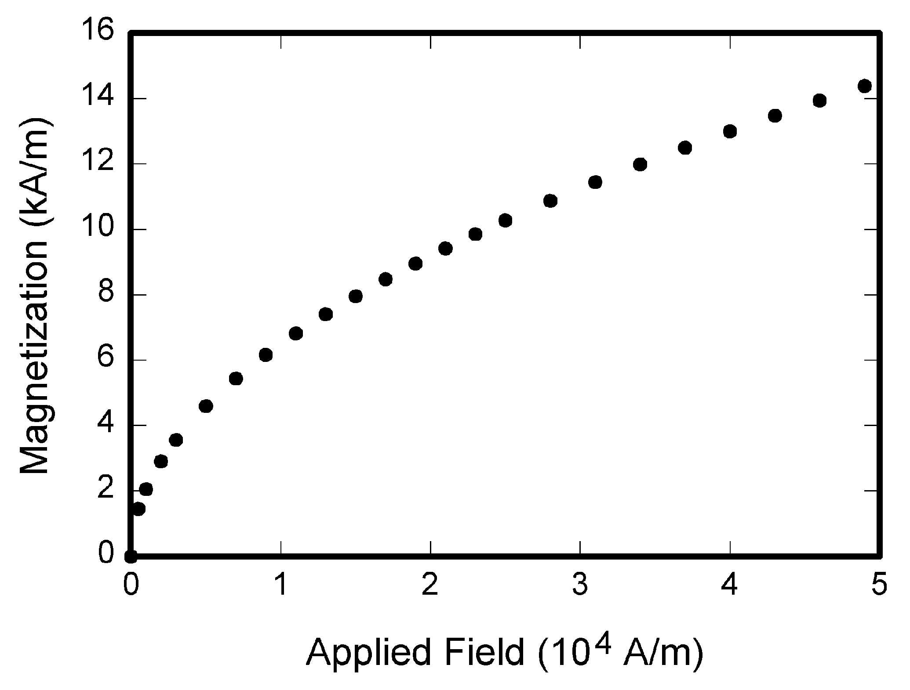
Fig. 1. Magnetization as a function of applied field. Note that “Fig.” is abbreviated. There is a period after the figure number, followed by two spaces. It is good practice to explain the significance of the figure in the caption.
When referencing your figures and tables within your paper, use the abbreviation “Fig.” even at the beginning of a sentence. Do not abbreviate “Table.” Tables should be numbered with Roman Numerals.

Conclusion
Although a conclusion may review the main points of the paper, do not replicate the abstract as the conclusion. A conclusion might elaborate on the importance of the work or suggest applications and extensions.

Appendix
Appendixes, if needed, appear before the acknowledgment.

Acknowledgment
Use the singular heading even if you have many acknowledgments. Avoid expressions such as “One of us (S.B.A.) would like to thank ... .” Instead, write “F. A. Author thanks ... .”

References and Footnotes
Use IEEE Citation Style: numbers enclosed in square brackets (e.g.: [1], [2], [3]). Citations should be numbered in the order they appear in the text. Punctuation follows the bracket [2]. Refer simply to the reference number, as in [3]. Use “Ref. [3]” or Reference [3]” at the beginning of a sentence: “Reference [3] was the first …”.
Give all authors’ names; use “et al.” if there are six authors or more. Papers that have not been published, even if they have been submitted for publication, should be cited as “unpublished” [4]. Papers that have been accepted for publication should be cited as “in press” [5]. For papers published in translated journals, first, give the English citation, then the original foreign-language citation [6].

Book
J. K. Author, Title of His Published Book, xth ed. City of Publisher, Country: Abbrev. of Publisher, year, ch. x, sec. x, pp. xxx–xxx.

Example:
[1] W.K. Chen. Linear Networks and Systems. Belmont, CA: Wadsworth, 1993, pp. 123-35.

Book Chapters
J. K. Author, “Chapter title” in Book title, xth ed. City of Publisher, Country: Abbrev. of Publisher, year, ch. x, sec. x, pp. xxx–xxx.
Example:
[2] J.E. Bourne. “Synthetic structure of industrial plastics,” in Plastics, 2nd ed., vol. 3. J. Peters, Ed. New York: McGraw-Hill, 1964, pp.15-67.

Article in a Journal
J. K. Author, “Article title”. Journal title, vol. , no., pp, date.
Example:
[3] G. Pevere. “Infrared Nation.” The International Journal of Infrared Design, vol. 33, pp. 56-99, Jan. 1979.

Articles from Conference Proceedings
J. K. Author, “Title of paper,” in Abbreviated Name of Conf., City of Conf., Abbrev. State (if given), Country, year, pp. xxxxxx.
Example:
[4] D. B. Payne and J. R. Stern, “Wavelength-switched pas- sively coupled single-mode optical network,” in Proc. IOOC-ECOC, Boston, MA, USA, 1985, pp. 585–590.

Patents
J. K. Author, “Title of patent,” U.S. Patent x xxx xxx, Abbrev. Month, day, year.
Example:
[5] E.E. Rebecca. “Alternating current fed power supply.” U.S. Patent 7 897 777, Nov. 3, 1987.

Standards

Title of Standard, Standard number, date.
Examples:
[6] IEEE Criteria for Class IE Electric Systems, IEEE Standard 308, 1969.

It is recommended that footnotes be avoided (except for the unnumbered footnote with the receipt date on the first page). Instead, try to integrate the footnote information into the text.

